YAML is a human-readable data serialization language (just like XML and JSON) that is often used for writing configuration files. It’s often an alternative to JavaScript Object Notation i.e JSON. YAML is case sensitive.
It provides a standardized format for representing structured data in a way that is both easily understandable to humans and interpretable by machines. “YAML” is an acronym which stands for "YAML Ain't Markup Language" or "Yet Another Markup Language." The former is meant to underscore that the language is intended for data rather than documents.
YAML is a popular programming language because it is designed to be easy to read and understand. It can also be used in conjunction with other programming languages. Because of its flexibility, and accessibility, YAML is used by Ansible to create automation processes, in the form of Ansible Playbooks. YAML files can be saved with either a .yaml or .yml extension (YAML files typically use extensions like .yaml or .yml)

YAML syntax heavily relies on indentation 0r spacing (usually 2 spaces) to represent the structure of data. You need to do consistent indentation or the YAML file will not validate and it will simply not work.
YAML can be used with all programming languages and is often used for configuration files, as well as data exchange and documentation. Its human-readable format enhances documentation clarity.
All Ansible playbooks are written in YAML. Ansible Playbooks are text files or configuration files rather that are written in a particular format called YAML. YAML is used to represent configuration data.
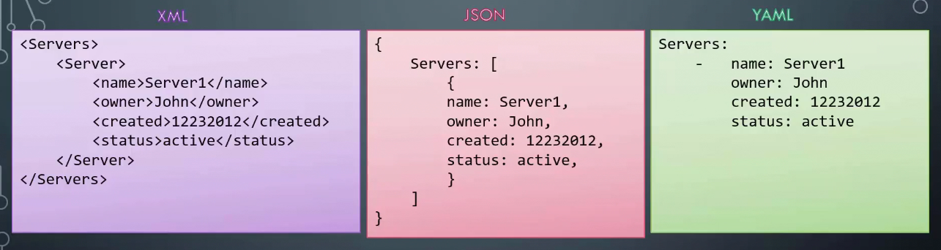

If you take the data in its simplest form, such as key-value pair, this is how you would define it in YAML - key and value separated by a colon (:). The keys are fruit, vegetable, liquid and meat and the values are apple, carrot, water and chicken. Remember, you must have a space followed by colon differentiating between the key and the value (key: value).
Let's take a look at how an array is represented. We would like to list some fruits and vegetables. We would say fruits followed by a colon. On the next line, enter each item with a dash in the front. The dash (-) indicates that it's an element of an array
A dictionary is a set of properties grouped together under an item. Here, we try to represent nutrition information of two fruits. The calories, fat, and carbs are different for each fruit. Notice the blank space before each item. You must have equal number of blank spaces before the properties of a single item, so they are all aligned together.
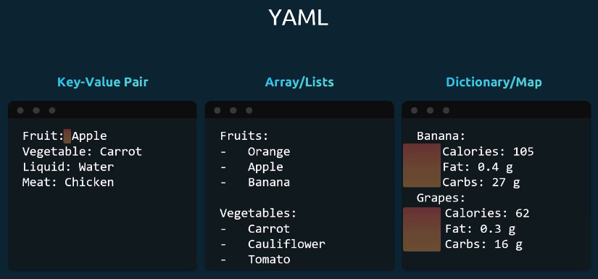
Let's take it to another level. You can have lists containing dictionaries containing lists. In this case, I have a list of fruits, and the elements of the list are banana and grape. But each of these elements are further dictionaries containing nutritional information.
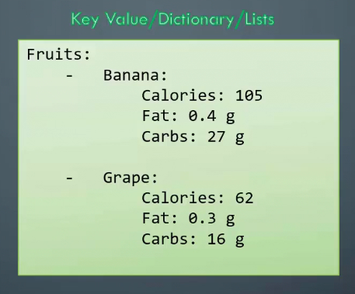
When to use a dictionary, list and list of dictionaries? (Dictionary vs List vs List of Dictionaries)
First of all, it is important to understand that all of what we discussed so far, such as XML, JSON, or YAML, are used to represent data.
Let's take an example of a car. A car is a single object, and it has properties such as color, model, transmission, and price. To store different information or properties of a single object, we use a dictionary. In this simple dictionary, I have properties of the car defined in a key-value format. This may not be as simple as this, for example, in case we need to split the model further into model name and make year, you could then represent this as a dictionary within another dictionary. In this case, the single value of model is now replaced by a small dictionary with two properties, name and year. So, this is a dictionary within another dictionary.
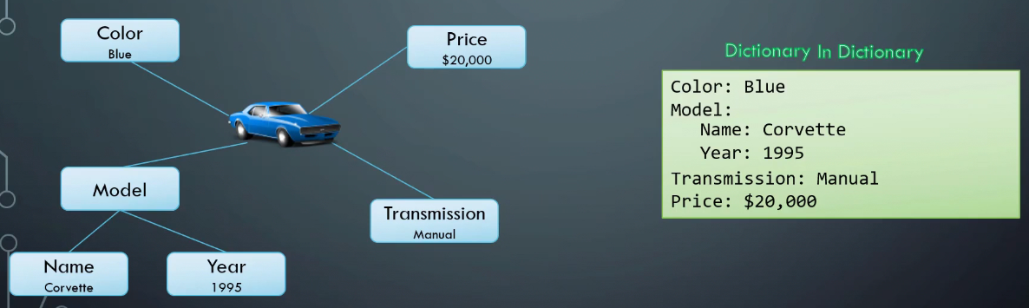
Let’s say, we would like to store the name of six cars. The names are formed by the color and the model of the car. To store this, we would use a list or an array as it is multiple items of the same type of object. Since we are only storing the names, we have a simple list of strings.
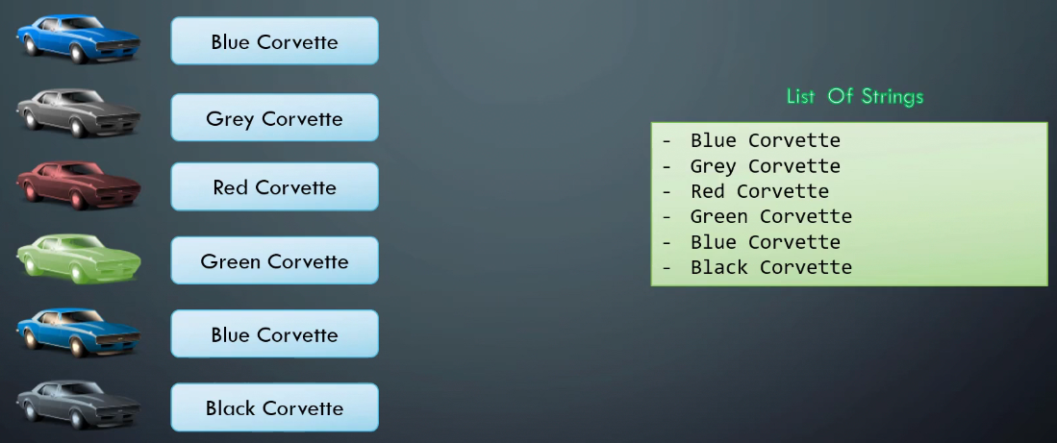
What if we would like to store all information about each car, everything that we listed before, such as the color, model, transmission, and price. We will then modify the array from a list of strings to a list of dictionaries. So, we expand each item in the array and replace the name with the dictionary we built earlier. This way, we are able to represent all information about multiple cars in a single YAML file using a list of dictionaries. So, that's the difference between dictionary list and list of dictionaries.
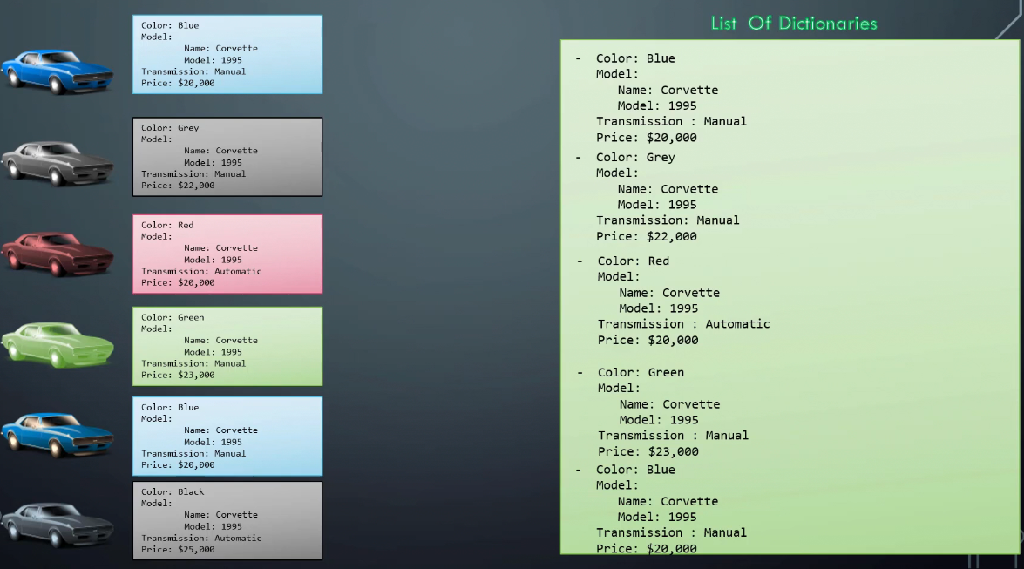

YAML Key Notes
Dictionary is an unordered collection, whereas lists are ordered collection. So, what does that mean? The two dictionaries that you see here have the same properties for banana. However, you can see that the order of properties fat and carbs do not match. In the first dictionary, fat is defined before carbs, and in the second dictionary, carbs comes first, followed by fat, but that doesn't really matter. The properties can be defined in any order, but the two dictionaries will still be the same as long as the values of each property match.
This is not the same for lists or arrays. Arrays are ordered collection, so the order of items matters. The two lists shown are not the same because apple and banana are in different positions. This is something to keep in mind while working with data structures. Also, remember, any line beginning with a hash (#) is automatically ignored and considered as a comment.

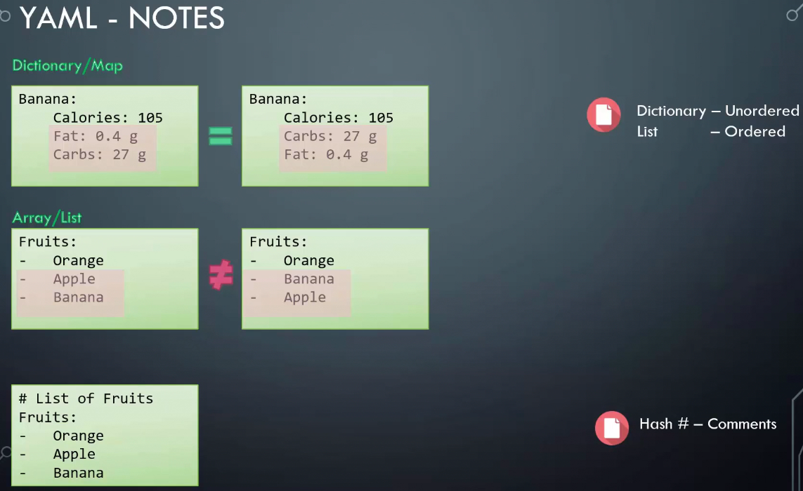

YAML Spaces
Let's take a closer look at spaces in YAML. Here, we have a dictionary representing the nutrition information of banana. The total amount of calories, fat, and carbs are shown. Notice the number of spaces before each property that indicates these key-value pairs fall within banana. But what if we had extra spaces for fat and carbs? Then they will fall under calories, and thus become properties of calories, which doesn't make any sense. This will result in a syntax error, which will tell you that mapping values are not allowed here because calories already have a value set, which is 105. You can either set a direct value or a hash map. You cannot have both. So, the number of spaces before each property is key in YAML. You must ensure they're in the right form to represent your data correctly.
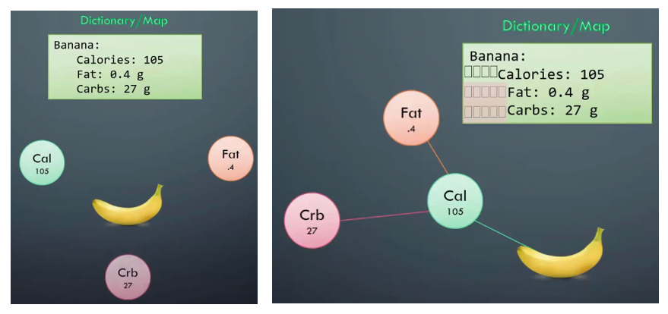
What is YAML used for?
One of the most common uses for YAML is to create configuration files. It's recommended that configuration files be written in YAML rather than JSON, even though they can be used interchangeably in most cases, because YAML has better readability and is more user-friendly.
In addition to its use in Ansible, YAML is used for Kubernetes resources and deployments.
A benefit of using YAML is that YAML files can be added to source control, such as Github, so that changes can be tracked and audited.

YAML in Ansible
Ansible Playbooks are used to orchestrate IT processes. A playbook is a YAML file containing 1 or more plays, and is used to define the desired state of a system.
Each play can run one or more tasks, and each task invokes an Ansible module. Modules are used to accomplish automation tasks in Ansible. Ansible modules can be written in any language that can return JSON, such as Ruby, Python, or bash.
An Ansible Playbook consists of maps and lists. To create a playbook, start a YAML list that names the play, and then lists tasks in a sequence. Remember that indentation is not an indication of logical inheritance. Think of each line as a YAML data type (a list or a map).
By using YAML templates, Ansible users can program repetitive tasks to happen automatically without having to learn an advanced programming language. Developers can also use the ansible-lint command, a YAML linter for Ansible Playbooks, to identify mistakes so errors don't occur during a critical stage of operation.

YAML and JSON share similarities in data representation, however, YAML stands out for its readability, expressiveness and support for complex data structures. YAML is a superset of JSON, meaning that it contains all the features of JSON in addition to expanded features and commands.

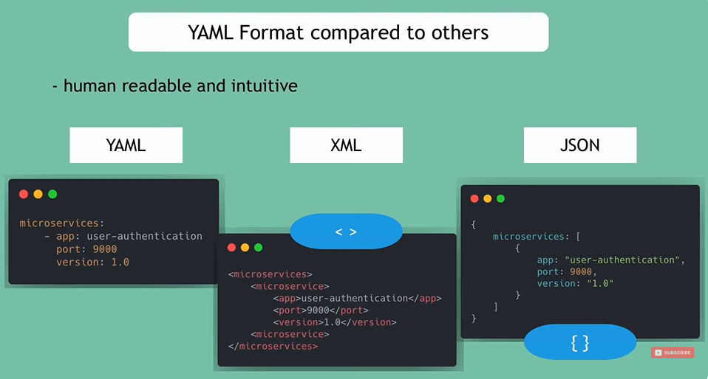

All YAML files (regardless of their association with Ansible or not) can optionally begin with --- and end with .... This is part of the YAML format and indicates the start and end of a document. That is just a requirement of YAML. It denotes the start of a YAML configuration file.
All members of a list are lines beginning at the same indentation level starting with a "- " (a dash and a space):

---
# A list of tasty fruits
- Apple
- Orange
- Strawberry
- Mango
...

YAML for Kubernetes
Kubernetes works based on defined state and actual state. Kubernetes objects represent the state of a cluster and tell Kubernetes what you want the workload to look like. Kubernetes resources, such as pods, objects, and deployments can be created using YAML files.
When creating a Kubernetes object, you’ll need to include specifications to define the object's desired state. The Kubernetes API can be used to create the object. The request to the API will include the object specifications in JSON, but most often you’ll provide the required information to kubectl as a YAML file. Kubectl will convert the file into YAML for you when it makes the API request.
Once an object has been created and defined, Kubernetes works to make sure that the object always exists. Developers or sysadmins specify the defined state using the YAML or JSON files they submit to the Kubernetes API. Kubernetes uses a controller to analyze the difference between the new defined state and the actual state in the cluster.
Kubernetes uses YAML files as inputs for the creation of objects such as pods, replicas, deployments, services, etc. All of these follow a similar structure. Every Kubernetes manifest shares four mandatory top-level fields. These fields tell Kubernetes what to create, how to version it, and any additional identifying metadata or configuration details. A Kubernetes definition file always contains four top level fields the API version, kind, metadata and spec. These are the top level or root level properties. These are also required fields, so you must have them in your configuration file.
- apiVersion: This is the version of the Kubernetes API we are using to create the object. Depending on what we are trying to create, we must use the right API version.
- kind: The kind refers to the type of object we are trying to create, which in this case happens to be a Pod. So, we will set it as Pod. Some other possible values here could be ReplicaSet or Deployment or Service
- metadata: The metadata is data about the object like its name, labels, etc. As you can see, unlike the first two (apiversion, kind) where you have specified a string value, this is in the form of a dictionary.
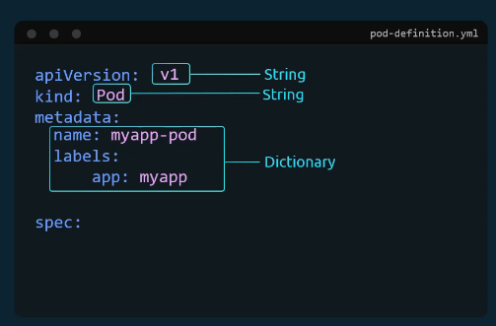
So, everything under metadata is intended to the right a little bit and so names and labels are children of metadata. The number of spaces before the two properties name and labels doesn't matter, but they should be the same as they are siblings. In this case, labels has more spaces on the left than name, and so it is now a child of the name property instead of a sibling, which is incorrect.
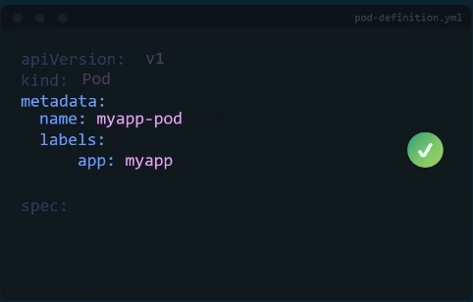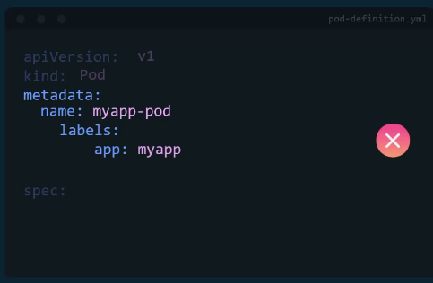
Also, the two properties must have more spaces than its parent, which is metadata, so that it's intended to the right a little bit. In this case, all three of them have the same number of spaces before them, and so they are all siblings, which is not correct under
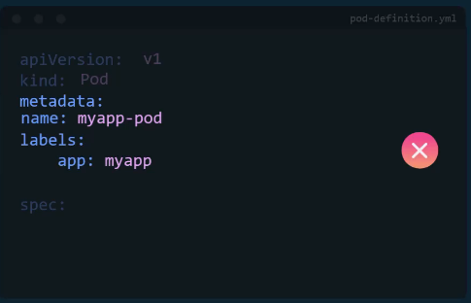
Under metadata the name is a string value, so you can name your pod myapp-pod and the labels is a dictionary. So, labels is a dictionary within the metadata dictionary and it can have any key and value pairs as you wish. For now I have added a label app with the value myapp. Similarly, you could add other labels as you see fit, which will help you identify these objects at a later point in time. Say for example, there are hundreds of pods running a front end application and hundreds of pods running a back end application or a database. It will be difficult for you to group these pods once they are deployed. If you label them now as front end, back end, or database, you will be able to filter the pods based on this label at a later point in time. It's important to note that under metadata, you can only specify name or labels or anything else that Kubernetes expects to be under metadata. You cannot add any other property as you wish under this. However, under labels you can have any kind of key or value pairs as you see fit.

- spec: So far, we have only mentioned the type and name of the object we need to create, which happens to be a pod with the name myapp-pod. But we haven't really specified the container or image we need in the pod. The last section in the configuration file is the specification section, which is written as spec. Depending on the object we are going to create this is where we would provide additional information to Kubernetes pertaining to that object. The spec section defines what's inside the object we are creating. This is going to be different for different objects. Since we are only creating a pod with a single container in it, it is easy. Spec is a dictionary, so add a property under it called containers. Containers is a list or an array. The reason this property is a list is because the pods can have multiple containers within them. In this case though, we will only add a single item in the list since we plan to have only a single container in the pod. The dash right before the name indicates that this is the first item in the list. The item in the list is a dictionary, so add a name and image property. The value for image is nginx, which is the name of the Docker image in the Docker repository.
Once the file is created, run the command kubectl create -f followed by the file name, which is pod-definition.yml and Kubernetes creates the pod.
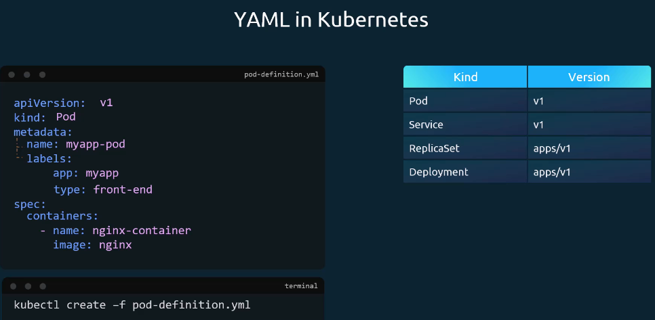

Pod with YAML
To create and manage Kubernetes Pods using a YAML file, you must define the Pod's desired state in a declarative manifest and apply it using the kubectl command-line tool. A Kubernetes YAML file for a Pod has four required top-level fields:
Field | Description | Example
apiVersion | API group and version for the resource | v1
kind | Type of Kubernetes object (Pod, Deployment, Service, etc.) | Pod
metadata | Key/value pair metadata, including name and labels | name: myapp-pod
spec | Desired state specification, varies per resource type | containers: [...]

Pod Definition Skeleton
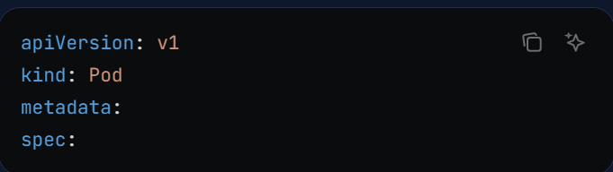

Detailed Field Breakdown
1) apiVersion: Defines the API group and version that Kubernetes will use to process this resource. For Pods, it’s always v1
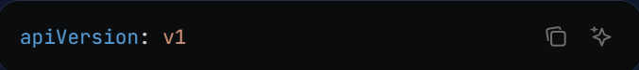
2) kind: Specifies the type of object to create. Other common values include Deployment, Service, and ReplicaSet.
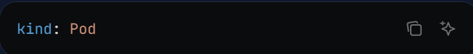
3) metadata: Contains identifying information such as the resource’s name and optional labels for grouping and selection.
- name: A unique identifier for the Pod within its namespace.
- labels: Arbitrary key/value pairs for organizational or selection purposes.
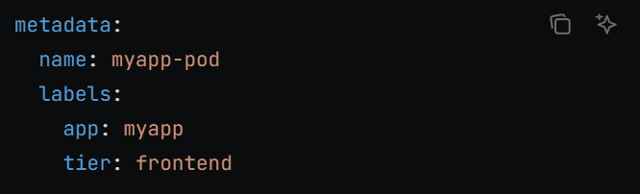
4) spec: Defines the desired state. In a Pod, this means listing the containers it should run.
- containers is a YAML list; you can define multiple containers per Pod.
- Each container requires at least a name and image.
- You can optionally define ports, environment variables, volume mounts, and more.
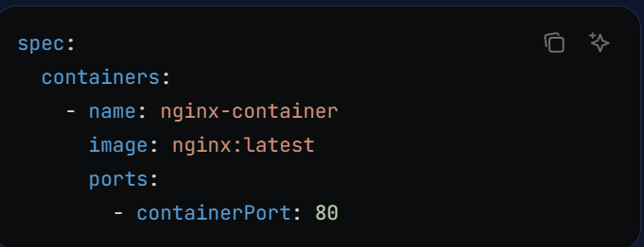
Create and Manage a Pod using YAML:
1) Save your manifest to .yaml (For e.g. pod-definition.yaml)
2) Run the following command to create the Pod:
>> kubectl create -f pod-definition.yaml or kubectl apply -f pod-defination.yaml
3) Check the list of pods available with kubectl get pods
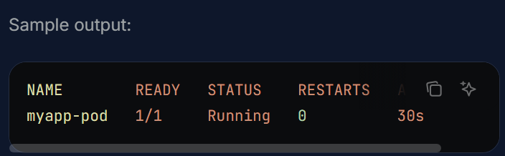
4) The kubectl get pods -o wide command is used to display a list of all the Pods in a Kubernetes cluster with additional information about each Pod. The -o wide flag gives you a more detailed output than the default kubectl get pods command.
5) Get detailed information about the pod using kubectl describe pod <pod-name> (Here pod name is myapp-pod). This will tell you information about the pod when it was created, what labels are assigned to it, what Docker containers are part of it, and the events associated with that pod.
6) Delete the Pod using kubectl delete pod <pod-name>
For production environments, consider using Deployments for managing Pod lifecycles, scaling, and self-healing. When configuring Pods, avoid hardcoding sensitive data and use ConfigMaps or Secrets instead. Defining resource requests and limits is also recommended for efficient allocation. To create a pod in a specific namespace through a YAML file, you must add the namespace field under the metadata section of your Pod definition file or specify the namespace via the command line as below
>> kubectl apply -f pod-defination.yaml -n <namespace-name>

Practice exercise 1: Instruction: Create a Kubernetes Pod definition file using values below:
- Name: postgres
- Labels: tier => db-tier
- Container name: postgres
- Image: postgres
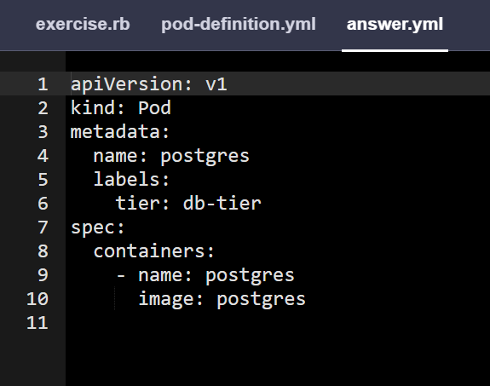

Practice exercise 2: Set an environment variable for the docker container. POSTGRES_PASSWORD with a value mysecretpassword.
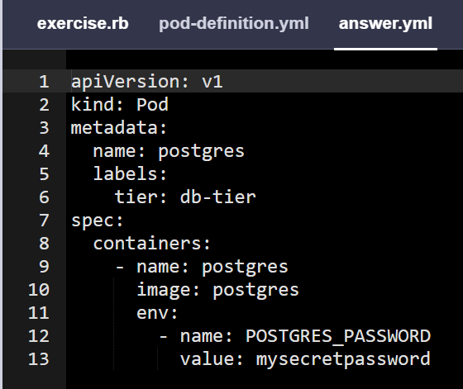

Practice exercise 3: Create a new pod with the name redis and the image redis123. Utilize a pod-definition YAML file. Please note that the image name redis123 is intentionally incorrect.
1) We use kubectl run command with --dry-run=client -o yaml option to create a manifest file
>> kubectl run redis --image=redis123 --dry-run=client -o yaml > redis-definition.yaml
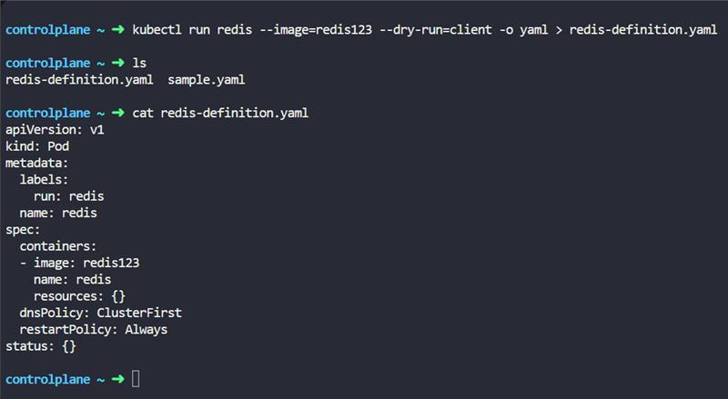
2) After that, using kubectl create -f command to create a resource (pod with name redis) from the manifest file.
>> kubectl create -f redis-definition.yaml
3) Verify the work by running kubectl get command
>> kubectl get pods
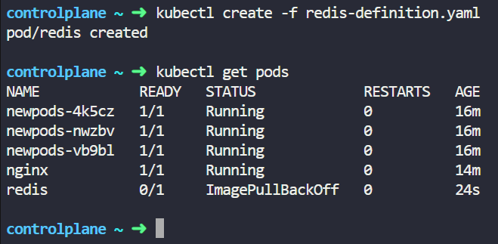
Practice exercise 4: Now change the image on this pod to redis.
Update the redis-definition.yaml file and use kubectl apply command or use kubectl edit pod <pod-name> command.
1) Use the kubectl edit command to update the image of the pod from redis123 to redis.
>> kubectl edit pod redis
Or
2) Update the image from redis123 to redis in the redis-definition.yaml file via vi or nano editor and then run kubectl apply command to update the image
>> kubectl apply -f redis-definition.yaml

